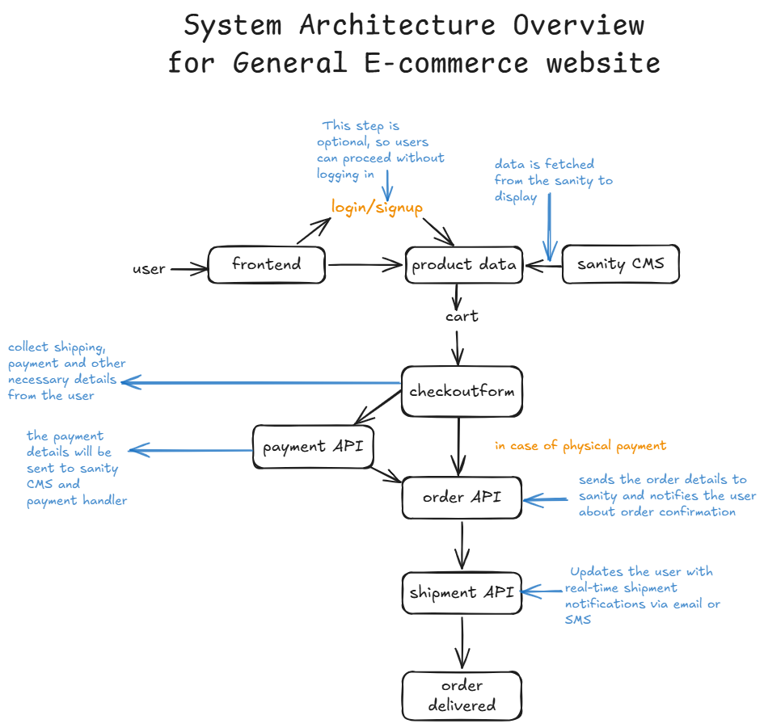

**API REQUIREMENTS AND ENDPOINTS**

1. **User Authentication Endpoints:**
   1. **api/auth/signup**

* **Method**: POST
* **Description**: Allows a new user to sign up by providing their details.
* **Response**: user ID
  1. **api/auth/login**
* **Method**: POST
* **Description**: Allows an existing user to log in with their credentials.
* **Response**: user ID

1. **Product Data Endpoints:**
   1. **api/products**

* **Method**: GET
* **Description**: Fetches a list of products from sanity CMS.
* **Response**: product ID, name, price, stock, image
  1. **api/products/[product]**
* **Method**: GET
* **Description**: Fetches detailed information for a specific product by its ID.
* **Response**: product ID, name, price, stock, image, description

1. **Order Management Endpoints**:
   1. **api/orders**

* **Method**: POST
* **Description**: Sends the order, payment method and shipping details to sanity CMS.
* **Response**: success, order ID

1. **Payment Endpoints:**
   1. **api/payment**

* **Method**: POST
* **Description**: Processes a payment for an order.
* **Response**: payment status

1. **Shipment Endpoints**:
   1. **api/shipment**

* **Method**: POST
* **Description**: Initiates the shipment process for an order.
* **Response**: shipment ID, tracking number, delivery date
  1. **api/shipment/[shipment ID]**
* **Method**: POST
* **Description**: Fetches the shipment status and tracking information for a specific shipment.
* **Response**: status, delivery date

**Sanity Schema Example**

export default defineType({

    name: "product",

    title: "Product",

    type: "document",

    fields: [

        {

            name: "title",

            title: "Title",

            validation: (rule) => rule.required(),

            type: "string"

        },

        {

            name:"description",

            type:"text",

            validation: (rule) => rule.required(),

            title:"Description",

        },

        {

            name: "productImage",

            type: "image",

            validation: (rule) => rule.required(),

            title: "Product Image"

        },

        {

            name: "price",

            type: "number",

            validation: (rule) => rule.required(),

            title: "Price",

        },

        {

            name: "tags",

            type: "array",

            title: "Tags",

            of: [{ type: "string" }]

        },

    ]

})